**Assignment No:- 13**

**Assignment Name:- Demonstrate Data Binding in Data list with Student Table ( Sno,Sname,Marks) using ADO.NET . Also demonstrate various templates.**

**Name:- WARKE PURVA DILIP.**

**Roll No:- 136.**

**----------------------------------------------------------------------------------------------------------------------------------------------------**

* **Default.aspx Page :-**

<%@ Page Language="C#" AutoEventWireup="true" CodeFile="Default.aspx.cs" Inherits="_Default" %>

<!DOCTYPE html>

<html xmlns="http://www.w3.org/1999/xhtml">

<head runat="server">

<title></title>

</head>

<body>

<form id="form1" runat="server">

<div>

<asp:Label ID="Label1" runat="server" Font-Bold="True" Font-Size="XX-Large" Text="Student Table "></asp:Label>

<br />

<br />

<asp:Label ID="Label2" runat="server" Font-Bold="True" Font-Size="Large" Text="Student Name : "></asp:Label>

<asp:TextBox ID="TextBox1" runat="server"></asp:TextBox>

<br />

<br />

<asp:Label ID="Label3" runat="server" Font-Bold="True" Font-Size="Large" Text="Student No : "></asp:Label>

<asp:TextBox ID="TextBox2" runat="server"></asp:TextBox>

<br />

<br />

<asp:Label ID="Label4" runat="server" Font-Bold="True" Font-Size="Large" Text="Student Marks : "></asp:Label>

<asp:TextBox ID="TextBox3" runat="server"></asp:TextBox>

<br />

<br />

<asp:Button ID="Button1" runat="server" Font-Bold="True" Font-Size="Large" OnClick="Button1_Click" Text="Submit " />

<br />

<asp:DataList ID="DataList1" runat="server" BackColor="#DEBA84" BorderColor="#DEBA84" BorderStyle="None" BorderWidth="1px" CellPadding="3" CellSpacing="2" DataSourceID="SqlDataSource1" GridLines="Both">

<FooterStyle BackColor="#F7DFB5" ForeColor="#8C4510" />

<HeaderStyle BackColor="#A55129" Font-Bold="True" ForeColor="White" />

<ItemStyle BackColor="#FFF7E7" ForeColor="#8C4510" />

<ItemTemplate>

Name:

<asp:Label ID="NameLabel" runat="server" Text='<%# Eval("Name") %>' />

<br />

No:

<asp:Label ID="NoLabel" runat="server" Text='<%# Eval("No") %>' />

<br />

Marks:

<asp:Label ID="MarksLabel" runat="server" Text='<%# Eval("Marks") %>' />

<br />

<br />

</ItemTemplate>

<SelectedItemStyle BackColor="#738A9C" Font-Bold="True" ForeColor="White" />

</asp:DataList>

<asp:SqlDataSource ID="SqlDataSource1" runat="server" ConnectionString="<%$ ConnectionStrings:MCAConnectionString2 %>" SelectCommand="SELECT * FROM [Student]"></asp:SqlDataSource>

</div>

</form>

</body>

</html>

* **Default.aspx.cs Page:-**

using System;

using System.Collections.Generic;

using System.Linq;

using System.Web;

using System.Web.UI;

using System.Web.UI.WebControls;

using System.Data.SqlClient;

using System.Data;

public partial class _Default : System.Web.UI.Page

{

string str = "server=DESKTOP-4J4I4PC\\SQLEXPRESS; initial catalog=MCA; trusted_connection=true";

protected void Page_Load(object sender, EventArgs e)

{

}

protected void Button1_Click(object sender, EventArgs e)

{

SqlConnection con = new SqlConnection(str);

con.Open();

string a = "insert into Student Values('" + TextBox1.Text + "','" + TextBox2.Text + "','"+TextBox3.Text+"')";

SqlCommand cmd = new SqlCommand(a, con);

cmd.ExecuteNonQuery();

TextBox1.Text = "";

TextBox2.Text = "";

TextBox3.Text = "";

con.Close();

}

}

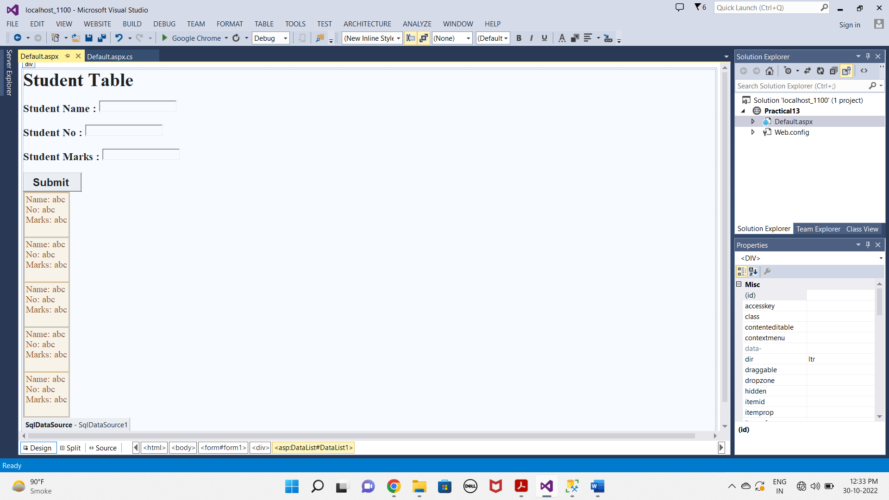

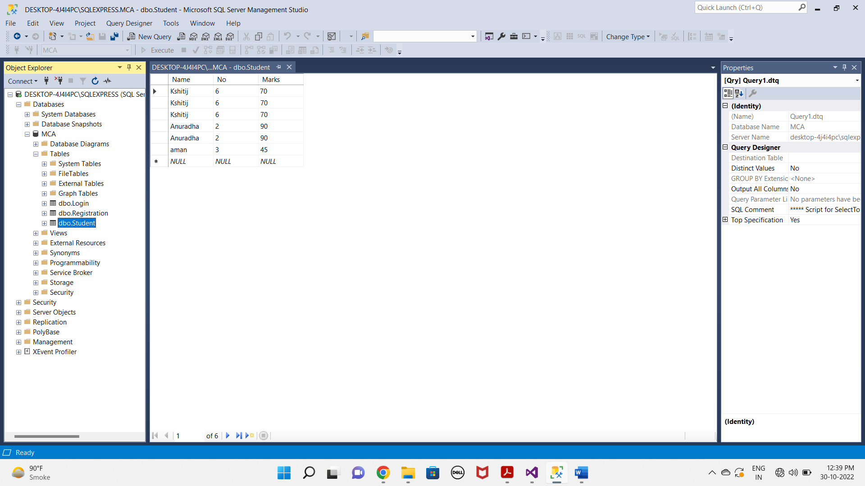

* **OUTPUT :-**

